API TESTING ASSIGNMENT:

URL :https://dummy.restapiexample.com/

URI : [https://dummy.restapiexample.com/api/v1/employees](https://dummy.restapiexample.com/api/v1/employees" \t "https://dummy.restapiexample.com/_blank)

Get Request :

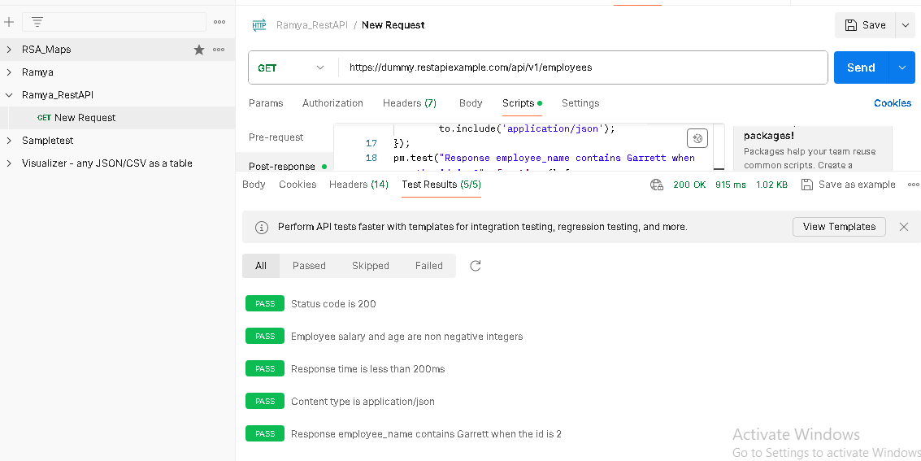

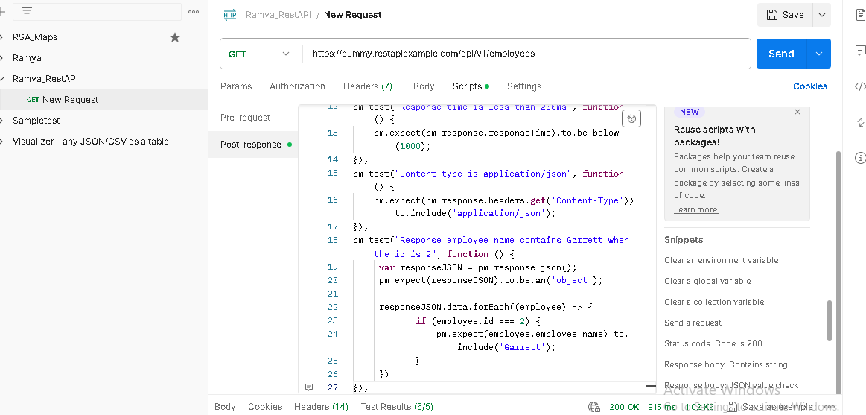

Post Request :

URI: <https://dummy.restapiexample.com/api/v1/create>

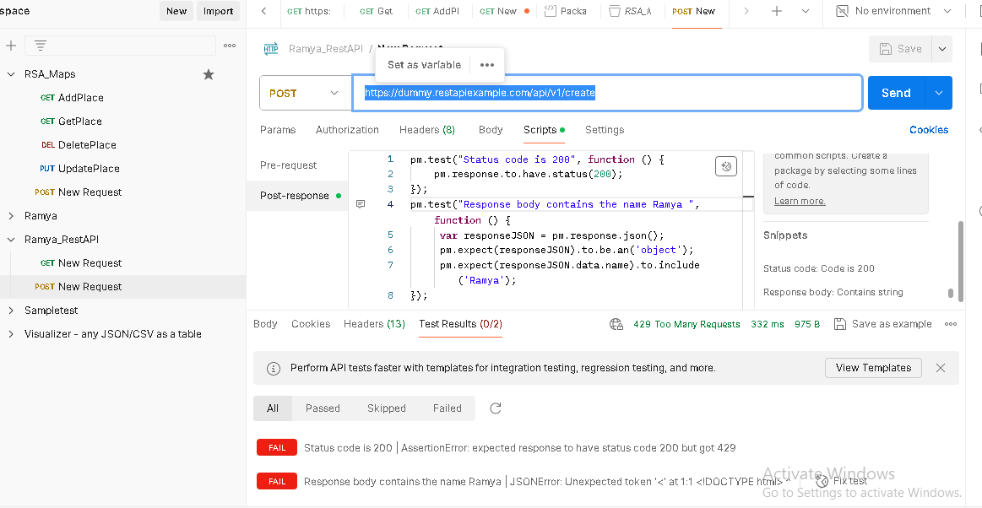

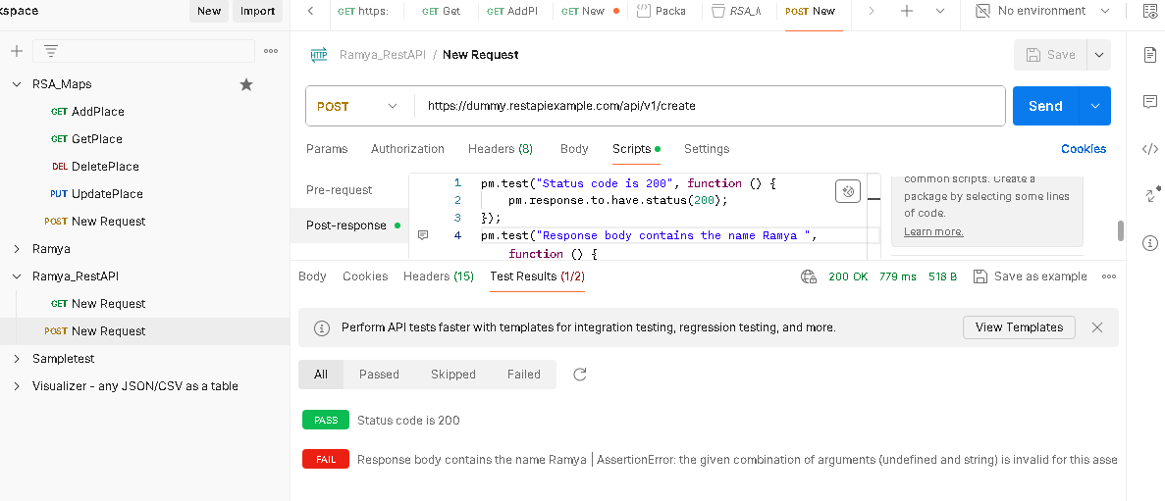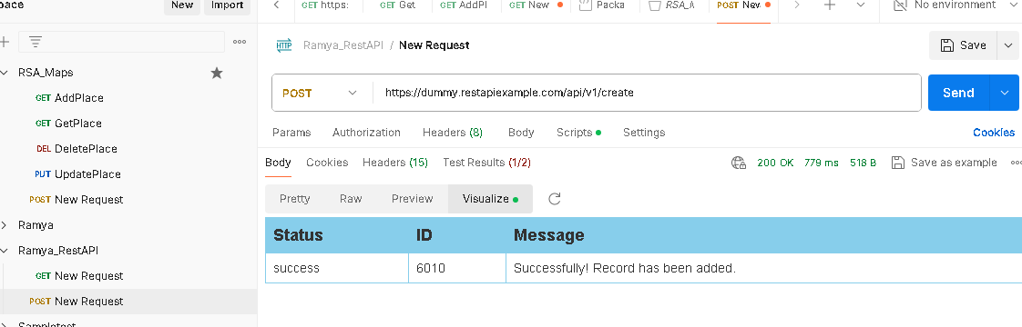

PUT Request :

URI :[https://dummy.restapiexample.com/api/v1/update/21](https://dummy.restapiexample.com/api/v1/update/21/" \t "https://dummy.restapiexample.com/_blank)

